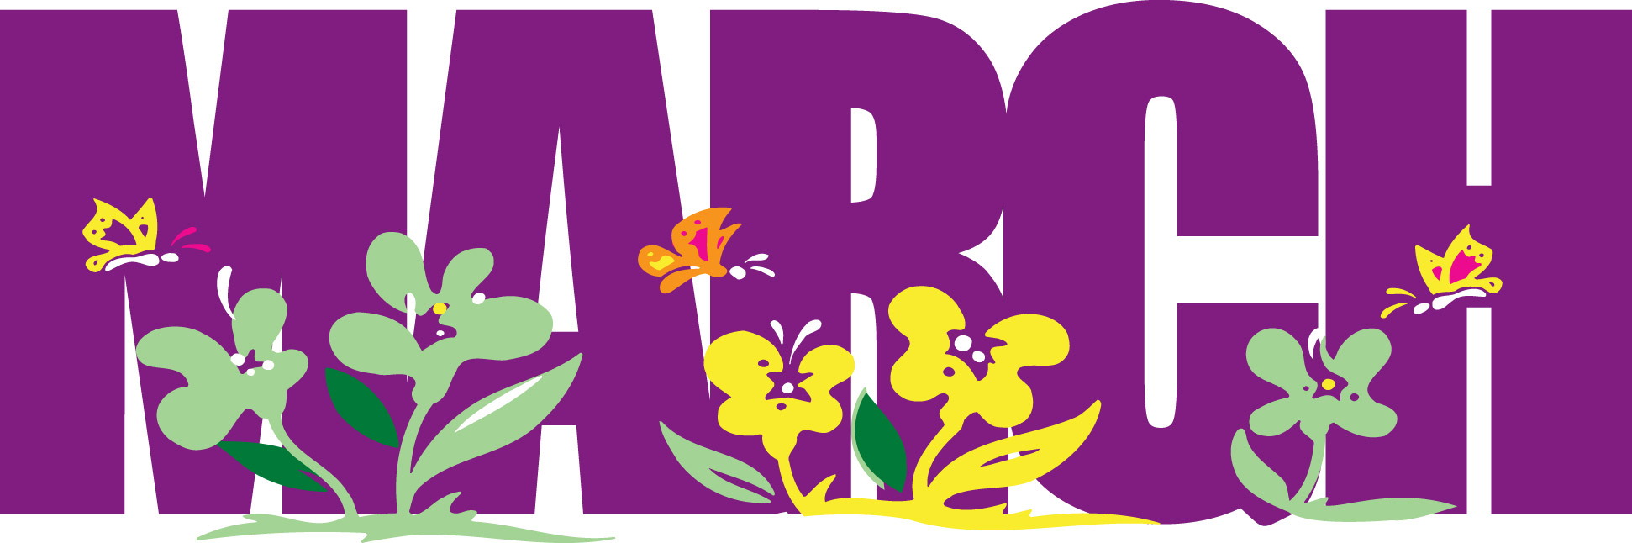
2022
School Website: https://secure1.nbed.nb.ca/sites/ASD-W/Chipman/Pages/default.aspx

Sunday | Monday | Tuesday | Wednesday | Thursday | Friday | Saturday
 |  | 1 | 2 | 3 | 4 | 5
 |  | Career Day-Dress up  MARCH BREAK | Book Character  /Super Hero Day – Dress up | PJ Day | Jersey Day
6 | 7 | 8 | 9 | 10 | 11 | 12
13 | 14 | 15 | 16 | 17 | 18 | 19
Clocks spring ahead | First Day back after March Break |  |  | ~Wear Green to celebrate St. Patrick’s Day
20 | 21 | 22 | 23 | 24 | 25  PL Day for Staff  NO SCHOOL FOR STUDENTS | 26  Purple Day-wear purple to raise awareness for Epilepsy
27 | 28 | 29 | 30 | 31 | April 1
THANK YOU: To all of those who donated special treats for Staff Appreciation Week! Your kindness and generosity are greatly appreciated.

School Closures:
Please listen to the local radio stations for announcements regarding school closures. Chipman Elementary is in Anglophone School District West and in Zone 8.
You may call 453-5454 after 6:00am or check out our website.

In the event that school may be cancelled during the day due to inclement weather we will contact students’ home to ensure safe arrival.

